Netaji Subhash Engineering College

Department of Computer Science & Engineering

B.Tech CSE 2nd Year 3rd Semester

2021-2022

Name of Course : IT Workshop

Course code : PCC – CS393

Name : Shubhradeep Maity

Class Roll No: 14

University Roll No: 10900120014

Date of Experiment: 17/11/2021

Date of Submission: 23/12/2021

_________________________________________________________________________________________________________

1. **Question No:** 39

* **Question:** Write a program to create a dictionary that contains (i, i*i) such that i is an integral number between 1 and n (both included)
* **Code:**

'''Write a program to create a dictionary that contains (i, i*i) such that i is an integral number between 1 and n (both included)'''

inp = int(input("Enter a number: ")) d = {} for i in range(1, inp+1):

d[i] = i*i print(d)

* **Snapshot:**

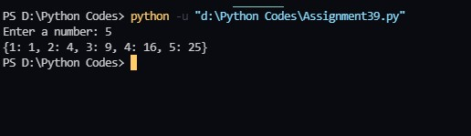

_________________________________________________________________________________________________________

2. **Question No:** 40

* **Question:** Write a program to count the numbers of characters in a string and store them in a dictionary.
* **Code:**

'''Write a program to count the numbers of characters in a string and store them in a dictionary.'''

str = input("Enter a string: ") d = {} for i in str:

if i in d:

d[i] += 1

else:

d[i] = 1

print(d)

* **Snapshot:**

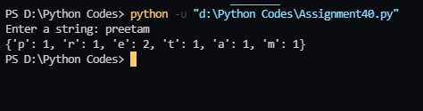

_________________________________________________________________________________________________________

3. **Question No:** 41

* **Question:** Write a program to create a dictionary by combining two lists ‘name’ for employee name and ‘salary’ for employee salary. Use the list ‘name’ as the key and ‘salary’ as the value of dictionary elements.
* **Code:**

'''Write a program to create a dictionary by combining two lists ‘name’ for employee name and ‘salary’ for employee salary. Use the list ‘name’ as the key and ‘salary’ as the value of dictionary elements.'''

nameList = input("Enter the names of employees separated by comma: ").split(",") salaryList = input("Enter the salaries of employees separated by comma: ").split(",") dist = {}

for i in range(len(nameList)):

dist[nameList[i]] = salaryList[i]

print(dist)

* **Snapshot:**

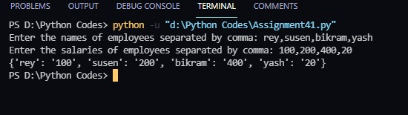

_________________________________________________________________________________________________________

4. **Question No:** 42

* **Question:** Write a program to input player's name (string) and runs (integer) scored for n number of players where n should be input from the keyboard. Store the player’s details in a dictionary called 'cricket'. After preparing the dictionary, input the player's name and print the runs scored by the player otherwise returns'-1' if the player's name is not found.
* **Code:**

'''Write a program to input player's name (string) and runs (integer) scored for n number of players where n should be input from the keyboard. Store the player’s details in a dictionary called 'cricket'. After preparing the dictionary, input the player's name and print the runs scored by the player otherwise returns'-1' if the player's name is not found.'''

n = int(input("Enter the number of players: ")) cricket = {}

for i in range(n):

name = input("Enter the name of player: ") runs = int(input("Enter the runs scored by the player: ")) cricket[name] = runs

while True:

name = input("Enter the name of player: ") if name in cricket:

print("The Score of player"+ name + "is",cricket[name])

else:

print("-1")

ch = input("Do you want to continue? (y/n): ") if ch == 'n':

break

● **Snapshot:**

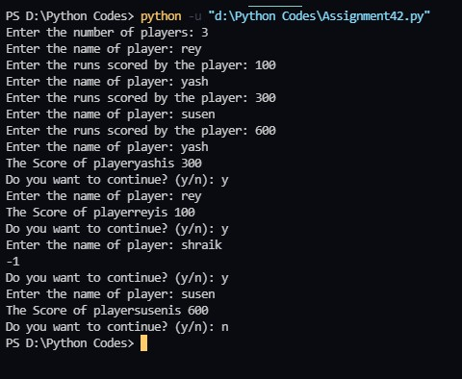

_________________________________________________________________________________________________________

5. **Question No:** 43

* **Question:** Write a program to sort (ascending order) a dictionary by value.
* **Code:**

'''Write a program to sort (ascending order) a dictionary by value.'''

dis = {'a':10, 'b':5, 'c':8, 'd':4, 'e':1}

sort_dis = sorted(dis.items(), key=lambda x: x[1]) print("before sorting\n",dis) print("After sorting\n",dict(sort_dis))

* **Snapshot:**

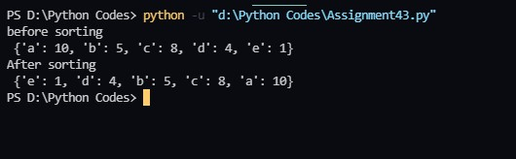

_________________________________________________________________________________________________________

6. **Question No:** 44

* **Question:** Write a program to merge two dictionaries.
* **Code:**

'''Write a program to merge two dictionaries.'''

dict1 = {'a':10, 'b':5, 'c':8, 'd':4, 'e':1} dict2 = {'f':20, 'b':15, 'g':18, 'h':14, 'e':11}

dict3 = {**dict1, **dict2} print("two dictionaries are\n") print(dict1) print(dict2) print("sorted dict is\n") print(dict3)

* **Snapshot:**

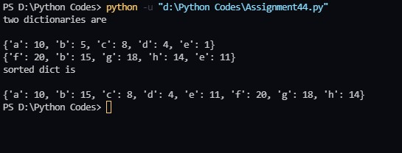

_________________________________________________________________________________________________________

Auto Generated with Assignmenty Bot. Check me out on github: github.com/ShreyamMaity/Assignmenty